# ****COMPOSITE TRANSFORMATIONS****

# NAME: - Mukul Dev

# REG NO.:-13BIT0269

# PROGRAM

#include <iostream>

#include <graphics.h>

#include <math.h>

#include <conio.h>

using namespace std;

int main()

{

int x1=200,y1=200,x2=250,y2=250,x3=180,y3=270,option;

initwindow(400,400,"transformations");

matrix(int x, int y)

{

if(y==m)

{

for(i=0;i<x;i++)

{

for(j=0;j<n;j++)

{

c[i][j]=0;

for(int k=0;k<m;k++)

{

c[i][j]=c[i][j]+a[i][k]*b[k][j];

}

}

}

}

else

{

cout<<"\n\nMultiplication is not possible";

}

}

do

{

line(x1,y1,x2,y2);

line(x2,y2,x3,y3);

line(x3,y3,x1,y1);

cout<<"\n1.Translation 2.Scaling 3.Rotation 4.Shearing 5.Exit\nEnter your choice:";

cin>>option;

switch(option){

case 1:

float tx,ty;

cout<<"Enter tx & ty: ";

cin>>tx>>ty;

matrix(tx,ty);

//x1+=tx;x2+=tx;x3+=tx;

//y1+=ty;y2+=ty;y3+=ty;

break;

case 2:

float sx,sy;

cout<<"Enter sx & sy: ";

cin>>sx>>sy;

matrix(sx,sy);

//x1*=sx;x2*=sx;x3*=sx;

//y1*=sy;y2*=sy;y3*=sy;

break;

case 3:

float deg;

cout<<"Enter angle: ";

cin>>deg;

deg = deg*3.14/180;

int x,y;

matrix(x,y);

break;

default:

cout<<"Invalid choice";

}

}while(option <= 4);

return 0;

}

# OUTPUT SCREEN

1.Translation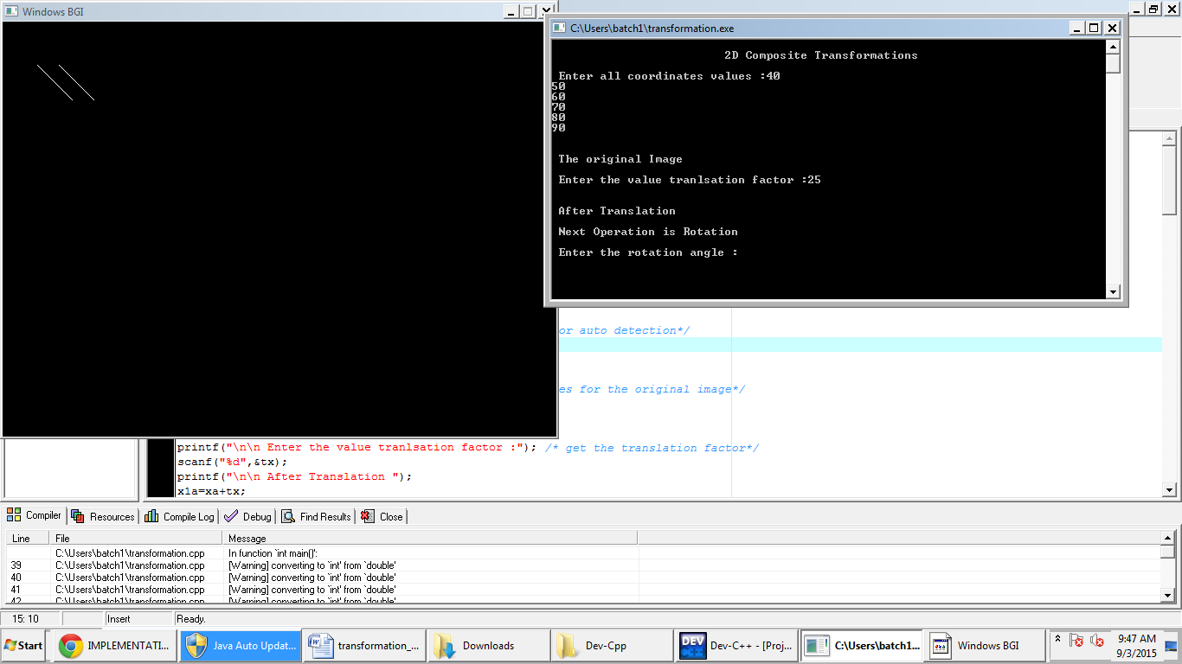

2.Rotation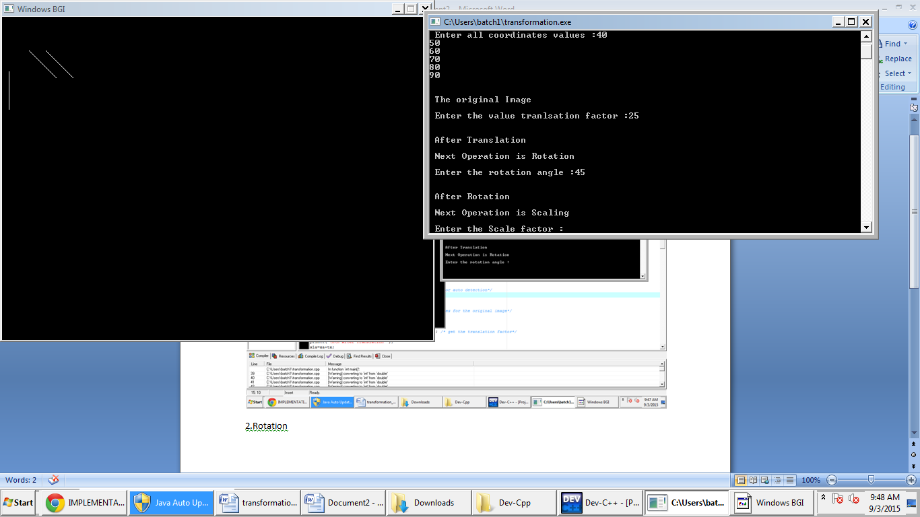

3.Scaling

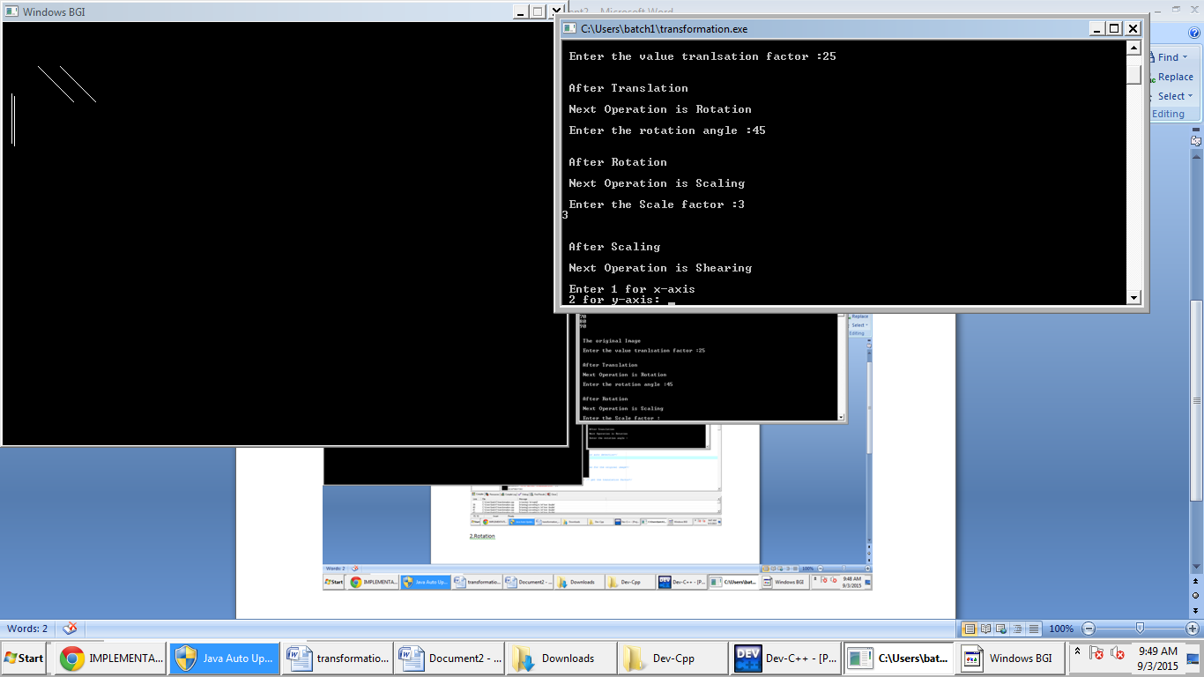

4.Shearing